**Thank you for purchasing the JD’s Garage Plasma Cutter Plans**

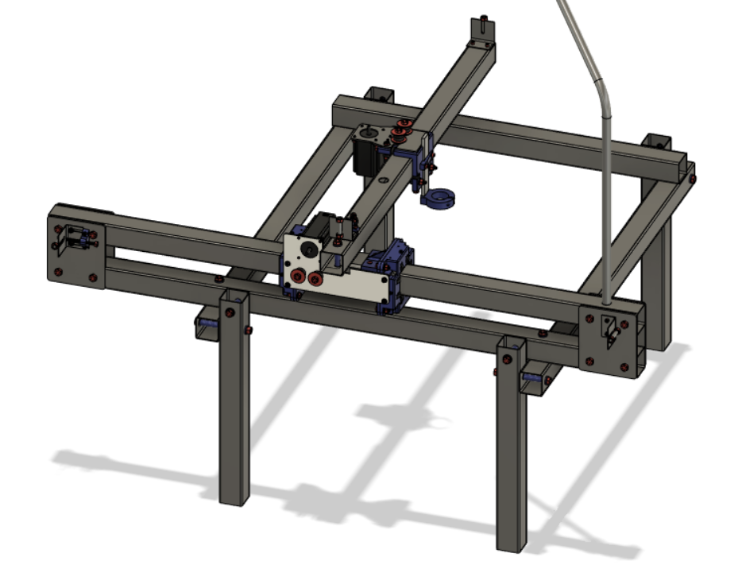

**What’s Included…**

**.**stl files for 3D printed parts

Drawings for all metal parts

BOM with links to purchase

Schematics and how to install software

Step by Step Assembly Instructions

**Current Revision V1.02**

While you are free to download the plans to your PC this is not recommended as updates and upgrades to the plans do come out. To ensure you are up to date, you can come back to the google drive for the most up to date version. There is a change log as well where you can see updates made to the plans.

**Sections:**

1 Tube Frame

2 Gantry

3 X-Axis

4 Motors and Belts

5 Wiring and software

Part Drawings

stl files and post processing instructions.

**How to get the most out of these instructions…**

1. Follow the sections is order it will make things easier
2. Read sections 1-4 before starting the build
3. Start by making 3D printed parts if you did not purchase them, make metal parts as they appear in the instructions
4. Use Pro Tips, they are there for a reason
5. There are 1:1 drawings for some of the metal pieces use them as templates
6. Use the Printer Calibration document to make sure your paper printer is printing to the correct scale. The title block is dimensioned on the Printer Calibration document and is the same size on all drawings.
7. There is a .stl file so you can print a drilling jig for the tubes
8. Watch build videos if you are confused as to how something may go together

**Sizing the Frame for Different Cutting Areas.**

**The current cutting area on the plasma cutter is 27.5” on the X axis and 31.5” on the Y axis. The X axis is the cantilever arm that holds the torch, and the Y axis is the gantry that holds the cantilever arm. Generally you do not want your belts to be longer than 5’ or they will lose precision and you do not want the cantilever arm to be longer than 45” so the theoretical maximum cutting area is 34.5” x 40.5”**

**If you want to change the cutting area you are going to have to make changes to the following tubes.**

**X-Axis**

**All three tubes in the X-axis direction are 38” long and the X-axis has the capacity to move 27.5” from hard stop to hard stop. So that would make our offset 10.5”. So if you wanted a machine that would have 24” of movement you would have to make the three pieces 34.5” long.**

**24 (movement length) + 10.5 (offset) = 34.5 (total Tube Length)**

**Y-Axis**

**The Y-Axis is a little more tricky but the same rules apply. There are two 51” pieces and one 30” piece in the Y Direction. The current movement length is 31.5” from hardstop to hardstop. So the offset on the longer pieces is 19.5” and on the shorter pieces it is -1.5” The longer pieces have a positive offset because they are longer than the movement and the shorter piece has a negative offset because it is shorter than the movement. Let’s say you wanted to change the Y axis to have 36” of movement the calculation would look like this.**

**Longe Pieces - 36 (movement length) + 19.5 (offset) = 55.5 (total tube length)**

**Short piece - 36 (movement Length) - 1.5 (offset) = 34.5 (total tube length)**

**Z-Axis**

**The Z-Axis is not necessary for running but may make your cutting experience more enjoyable and consistent. If you choose to use the Z-Axis you need to use the Z-Axis variant of the 51” Lower Y-Frame Rail. The drawing is in the “Drawings” folder along with all the other drawings.**

**Tips and Best Practices**

**Refer to the CNC build series on our YouTube page.** [**CNC Plasma Cutter - YouTube**](https://www.youtube.com/playlist?list=PLWACT6mAqAyVz0Aqc3zoBX9DPsVudicCc)

**Y-axis bearing supports, do not attach to bearing supports to the mounts until bearings are adjusted for proper fit on tubing. The sides with 3 set screws should be facing upward and inward. Adjust the top bearings first. Tighten center set screw until just snug. Roll bearing assembly back and forth along the tube keeping it perpendicular to the tube, loosen slightly if necessary. There should be no play. tighten the outer 2 set screws until only slight resistance is felt. Move to the inside plane and follow the previous step to adjust that set of bearings. Repeat the procedure with the second bearing support. We have found that it is best not to remove the bearing assembly from the tube once the bearing load is set. If you have rough spots when moving the bearings, use a large flat file and smooth out the areas where the bearing run. Attach the bearing supports to the bearing support mounts with eight 1/4" bolts. Do not tighten. The X-axis arm must be level to the bed before tightening. Take measurements nearest the Y-axis and furthest outward. Both must be the same. Once these are the same, tighten the 8 bolts and recheck. This must be perfect. If you can't get the dimensions equal, try drilling out the 8 holes in the bearing support mounts 1 size bigger.**

**X-axis must be plumb to the bed surface. Process: Adjust the lower adjustable bearings so they are not touching the tube. Slightly tighten 1/4" bolts on upper adjustable bearings. Use a square to measure from bed to aluminum torch holder. Adjust the upper set screws to achieve plumb. Firmly tighten 1/4" bolts. Adjust lower bearings so they just make contact with the tube and check that they spin when moving the assembly. Firmly tighten the lower 1/4" bolts on the adjustable bearings. Check that there is no play or rack on the X-axis bearing assembly.**

**If the CNC machine will be exposed to below freezing temperatures for more than a few hours, we recommend loosening the bearing support set screws 1/16 of a turn.**

**Do not expose the 3D printed parts to direct sunlight for extended periods of time.**

**Only use light torque when tightening any of the bolts/sets screws that are tapped into the 3D printed parts.**

**Many of the parts listed in the Bill of Materials can be purchased off of eBay cheaper than Amazon.**

**CRITICAL: The 2" square tubing that makes up the X-axis must be 0.065" wall thickness tube or thinner. The bearing/gantry assembly will not support a heavier tube. The rest of the machine can be made out of thicker tubing.**

**CRITICAL: You must use a low frequency start plasma cutter (blow back start) to avoid interference with the CNC machine's electronics. We used a Lotos LTP5500DCNC.** [**Lotos Supreme LTP5500D Non-Touch Pilot Arc Plasma Cutter, Dual Voltage 110V/220V, 3/5 inch Clean Cut, Brown (55AMP Digital): Amazon.com: Tools & Home Improvement**](https://amzn.to/3XoqiMZ)

LEGAL: JD’s Garage is the sole creator and owner of these plans. JD’s Garage is the only source for these plans. JD’s garage does not authorize these plans to be resold or redistributed in any form or modification hereafter. JD’s Garage does not authorize resale, or redistribution in any form. Plans user (you) releases, discharges, and relinquishes all liability from JD’s Garage when opening these plans. JD’s Garage retains indemnity, is saved, protected, and held harmless from all forms of liability from the use of these plans. Plans User (you) assume all responsibility and liability from the moment you view, share and/or use these plans.